TITLE
Smart Mini Washing Machine Prototype Using Arduino Uno and ROBO ESP32
AUTHORS
Muhammad Haikal Zulhilmi Bin Fairof (2313025), Muhammad Faiz Izwan Bin Nor Effendi (2313509), Ainul Jaariah Binti Aliudin (2312664), Department of Mechatronics Engineering, International Islamic University of Malaysia (IIUM), Email: haikalzulhilmi11@gmail.com

ABSTRACT
This report presents the design and development of a Smart Mini Washing Machine prototype as part of the Mechatronics System Integration (MSI) Mini Project. The prototype demonstrates effective integration of sensors, actuators, microcontrollers, and user interface components to simulate an automated washing process at a scaled-down level. A dual-microcontroller architecture is implemented, where an Arduino Uno is responsible for real-time control tasks, while a ROBO ESP32 supports system monitoring and future expandability. The system utilizes a weight sensor to detect laundry load conditions and an ultrasonic sensor to monitor water level before initiating operation. A DC motor simulates drum rotation, while LEDs and an LCD module provide real-time visual feedback of system status. User interaction is enabled through start/stop and reset push buttons. Experimental testing shows that the prototype operates reliably under defined conditions, demonstrating the fundamental principles of embedded control, sensor interfacing, and system integration applied to a household automation system.

1. INTRODUCTION
Household appliances such as washing machines play an important role in daily life by providing convenience, efficiency, and improved hygiene. Modern washing machines rely heavily on embedded systems that integrate sensors, actuators, control algorithms, and user interfaces to perform automated washing operations [1], [3]. These systems represent a practical application of mechatronics system integration, where mechanical, electrical, and software components work together to achieve reliable and safe operation [4].
Although commercial washing machines are highly advanced, their internal control systems are complex and not easily accessible for educational purposes [5]. This limits hands-on learning opportunities for students to understand fundamental concepts such as sensor interfacing, actuator control, real-time decision making, and system-level integration [6]. Therefore, developing a scaled-down prototype provides a suitable platform to study and demonstrate the principles of mechatronics system integration in a controlled and simplified environment [7].
In recent years, embedded controllers such as Arduino and ESP32 have been widely used in educational and prototype-based automation projects due to their flexibility, low cost, and strong community support [2], [8]. By utilizing these controllers, students can explore the interaction between hardware and software while implementing real-time control strategies similar to those found in industrial and household systems [9].
This project focuses on the design and development of a Smart Mini Washing Machine prototype that simulates essential washing functions, including load detection, water level monitoring, controlled motor operation, and user interaction. A dual-microcontroller architecture is implemented using an Arduino Uno and a ROBO ESP32 to demonstrate task partitioning between real-time control and system monitoring [10]. The objectives of this project are to apply mechatronics system integration concepts, implement embedded control logic for an automated process, and provide an educational prototype that reflects the operation of a real washing machine at a simplified level.

2. METHODOLOGY

2.1 Project Development
The Smart Mini Washing Machine prototype features a dual-microcontroller architecture (Arduino Uno and ESP32), designed to enhance system modularity, reliability, and scalability. The Arduino Uno serves as the primary controller, responsible for time-critical and deterministic tasks such as sensor data acquisition, motor control, LED indication, LCD updates, and handling push-button inputs. These tasks require fast response and predictable timing, making the Arduino Uno suitable for real-time control operations. Figure 1 will show the combined block diagram of the Arduino Uno system connections. The Cytron ROBO ESP32 is interfaced with an ultrasonic sensor to perform clothes counting and transmit the resulting data to a mobile phone. Additionally, it receives operational data from the Arduino Uno via serial communication. The Arduino Uno is connected to a load sensor to measure the weight of the clothes and forwards this information to the mobile phone. This configuration enables the system to display both the clothes count and their weight on a mobile device, effectively integrating data from two controllers for enhanced monitoring and analysis. Figure 2 will show the combined block diagram of the ESP32 system connections. All system components are interconnected to form a complete automated washing cycle. The interaction between sensors, actuators, and controllers enables the system to make decisions based on real-time conditions, ensuring safe and reliable operation.
Arduino Uno
START Button
Red LED
STOP Button
Load Sensor
Green LED
DC motor with Encoder
Buzzer
16x2 I2C LCD
Figure 1: Block Diagram of Arduino Uno System Connections

ESP 32 with
Cytron Robo ESP 32
Ultrasonic Sensor
Send information to mobile phone
Figure 2: Block Diagram of ESP 32 System Connections

2.2 Sensors and Actuators
- Weight Sensor: Measures the load inside the washing drum to determine whether the washing process can begin safely.
- Ultrasonic Sensor: Detects water level inside the container to ensure sufficient water is present during operation.
- DC Motor: Simulates the washing drum rotation.
- LED Indicators (RED & GREEN): Indicate motor rotation direction or operational state (ON/OFF).
- LCD Display: Displays system information such as washing status, sensor readings, and process stages.

2.3 User Interface Components
- Start/Stop Button: Initiates or pauses the washing process.
- Reset Button: Resets the system to its initial state.

2.4 Schematic Diagram and Prototype Setup
The electrical connections and hardware arrangement of the Smart Mini Washing Machine prototype are illustrated in Figures 3 and 4. Figure 3 shows the system’s schematic diagram, including the Arduino Uno, ROBO ESP32, load sensor, ultrasonic sensor, DC motor driver, LEDs, LCD module, and push buttons, along with the serial communication link between the two microcontrollers. Figure 4 presents the physical prototype, demonstrating the placement of sensors, actuators, and controllers in a compact layout, with the ultrasonic sensor facing the water container, the load sensor beneath the drum, and LEDs and LCD providing real-time feedback. Together, these figures provide a clear understanding of both the theoretical and practical hardware implementation of the automated washing system.

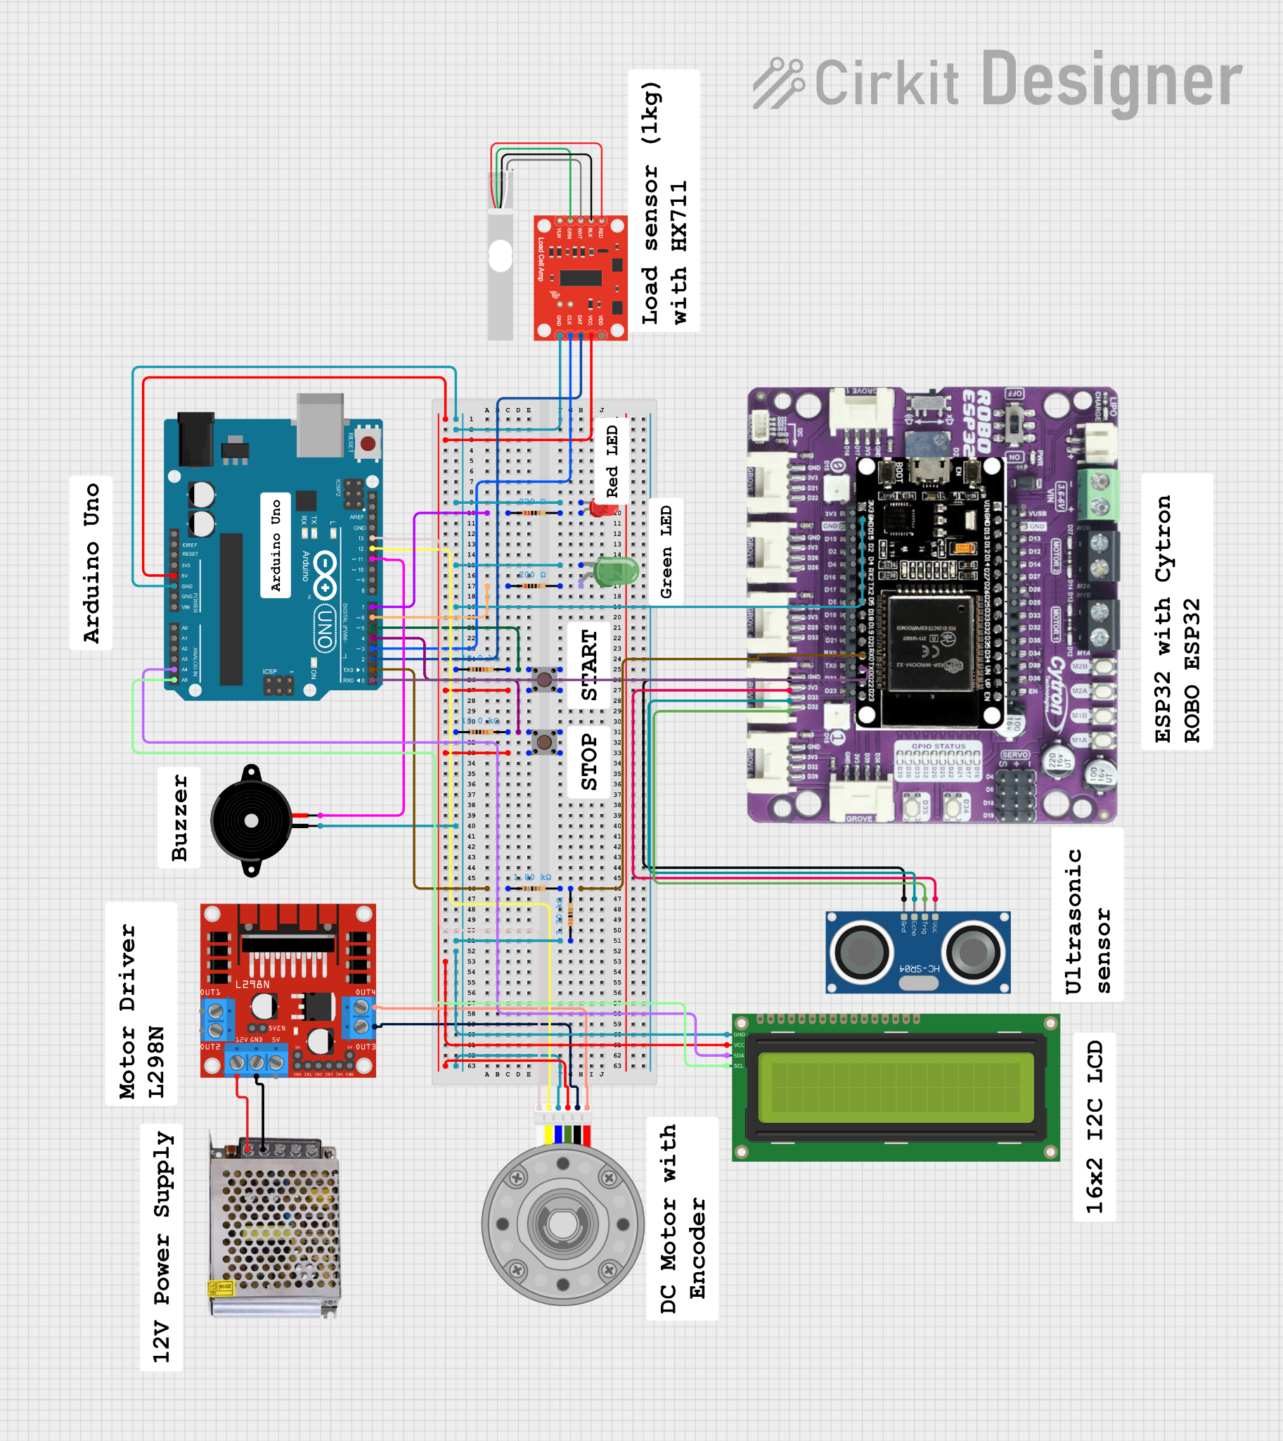
Figure 3: Electric Design of The System
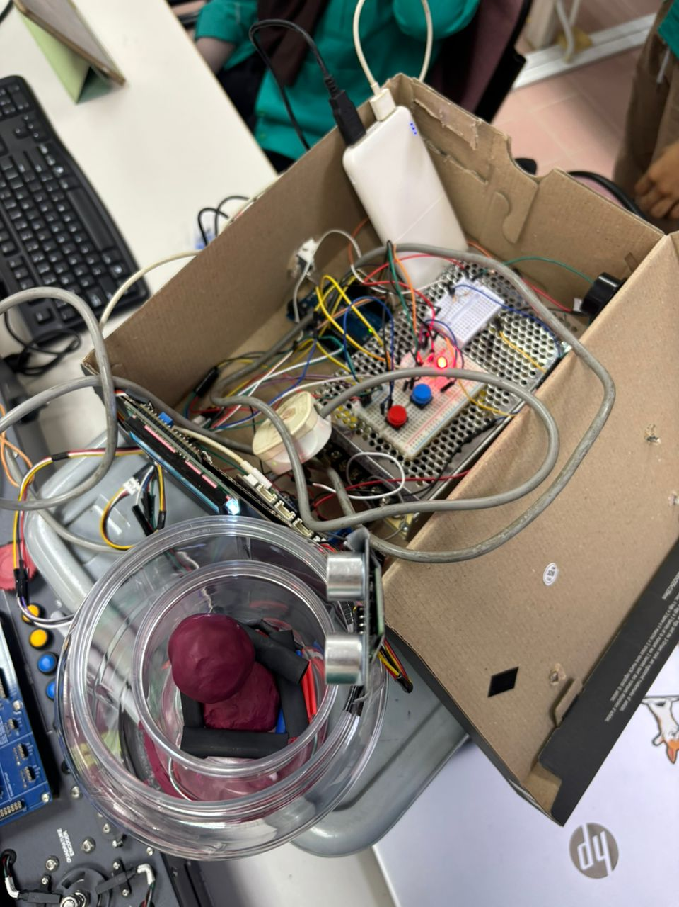
Figure 4: Physical Setup of the Smart Mini Washing Machine Prototype

3. HARDWARE IMPLEMENTATION
The hardware implementation of the Smart Mini Washing Machine prototype consists of an Arduino Uno interfaced with multiple peripheral components, including a load (weight) sensor, ultrasonic sensor, DC motor driver, light-emitting diodes (LEDs), liquid crystal display (LCD) module, and push-button switches. The DC motor is driven through a dedicated motor driver circuit to ensure safe and reliable operation by providing adequate current amplification and electrical isolation between the motor and the microcontroller.
LED indicators are connected to the digital output pins of the Arduino Uno and are programmed to illuminate when the motor is in operation, providing a simple visual indication of system activity. The ultrasonic sensor is positioned to face the water container, enabling accurate measurement of the water level through distance sensing. The load sensor is installed beneath the container or drum to measure the applied load, allowing the system to prevent operation under excessive weight conditions.
The ROBO ESP32 is interfaced with the Arduino Uno via serial communication to receive system data, such as load measurements and operational status, and to enhance overall processing and monitoring capability. This communication enables efficient data exchange between the two controllers while maintaining separation of real-time control and monitoring functions.
Power is supplied through a regulated DC power source suitable for both microcontrollers and the DC motor. Proper voltage regulation and grounding are implemented to ensure stable system operation and to protect sensitive electronic components from voltage fluctuations.

4. SOFTWARE AND CONTROL STRATEGY

4.1 Control Logic Using Arduino Uno
The Arduino Uno executes the main control algorithm by continuously monitoring input signals from the load (weight) sensor and ultrasonic sensor. Upon activation of the start button, the system evaluates whether the measured load weight is within the predefined safe operating range and whether a sufficient water level is detected. If both conditions are satisfied, the DC motor is activated to initiate the washing cycle.
During motor operation, LED indicators are switched ON to provide visual confirmation of motor rotation. Simultaneously, the LCD module displays the current operational stage of the system, such as “Checking Load”, “Filling Water”, “Washing”, or “Stopped”, thereby enhancing user interaction and system transparency.
A stop function is implemented to allow the user to pause the washing process at any time, while a reset button clears all system states and returns the controller to the idle condition. This control logic ensures safe, user-controlled, and deterministic operation of the washing cycle.

4.2 ROBO ESP32 Integration
The ROBO ESP32 functions as a secondary controller responsible for receiving operational data from the Arduino Uno via serial communication. This data can be utilized for extended processing, system monitoring, or future feature expansion, such as wireless data transmission or mobile application integration. The separation of control and monitoring tasks between the Arduino Uno and the ESP32 improves system scalability and reflects common practices in real-world embedded and industrial control system designs.

4.3 System Flow Sequence
The overall operational sequence of the Smart Mini Washing Machine prototype is summarized as follows:
- System initialization and idle state
- User presses the start button
- The load condition is evaluated using the weight sensor
- Water level is verified using the ultrasonic sensor
- The DC motor is activated to initiate the washing process
- LED indicators illuminate to indicate motor operation
- LCD updates and displays the current process status
- User presses the stop or reset button to terminate operation
Figure 5 illustrates the system flowchart that describes the complete operational sequence of the washing process.

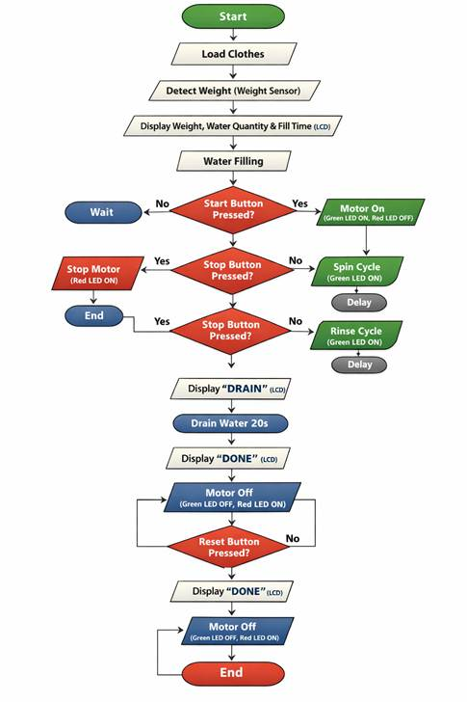
Figure 5: Flowchart of the Smart Mini Washing Machine Operation

5. RESULTS AND DISCUSSION

5.1 Arduino Uno System Analysis
The Smart Mini Washing Machine prototype operated as intended during experimental testing. The load (weight) sensor successfully detected excessive load conditions and prevented the system from initiating operation when the predefined threshold was exceeded. This behavior enhanced system safety by protecting the motor and mechanical components from overload conditions.
The ultrasonic sensor used for water level detection provided consistent and reliable measurements, ensuring that the motor operated only when a valid water level was detected. This conditional control prevented dry operation of the motor and demonstrated effective implementation of sensor-based decision-making within the control logic.
The LCD module displayed clear and continuous feedback on system status, including operational states and sensor readings, thereby improving user interaction and system transparency. In addition, LED indicators effectively reflected motor activity, allowing quick visual confirmation of system operation. The dual-microcontroller configuration exhibited stable serial communication, with the Arduino Uno efficiently handling real-time control tasks while coordinating data exchange with the ROBO ESP32. Overall, the Arduino Uno subsystem demonstrated reliable performance and effective integration of sensors, actuators, and user interface components within the automated washing process.

5.2 ESP32 System Analysis
The ROBO ESP32 subsystem functioned effectively as a monitoring and communication controller within the dual-microcontroller architecture. The ultrasonic sensor, interfaced with the ESP32, successfully performed clothes counting by detecting object presence and distance variations. The processed clothes count data was transmitted reliably to a mobile phone, enabling real-time remote monitoring of the washing process.
Furthermore, the ESP32 received operational data from the Arduino Uno through serial communication, including load sensor readings. This data integration allowed the mobile interface to display both the number of clothes and their corresponding weight, providing a comprehensive overview of system conditions. The ESP32’s wireless communication capability enhanced system functionality by extending user interaction beyond the physical interface.
The separation of tasks between the Arduino Uno and ESP32 improved overall system efficiency by allocating time-critical control operations to the Arduino Uno while assigning data handling, monitoring, and communication tasks to the ESP32. This architecture demonstrated effective task partitioning and highlighted the advantages of using multiple microcontrollers in complex mechatronic systems.

5.3 Clothes Counting and Mobile App Display
The ROBO ESP32 subsystem successfully counts the number of clothes using the ultrasonic sensor. This data is transmitted to a mobile application, providing real-time monitoring of the washing process. Figure 6 illustrates how the clothes count is displayed in the mobile app interface.

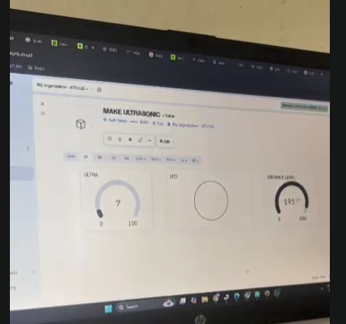
Figure 6: Mobile Application Interface Showing Clothes Counting Output from the ESP32 System

As shown in Figure 6, the mobile application receives processed data from the ESP32, displaying both the number of clothes and, if integrated, the corresponding load weight. This visualization allows users to monitor washing conditions remotely and demonstrates the effectiveness of dual-controller integration for data processing and communication in embedded systems.

6. CONCLUSION
In conclusion, the Smart Mini Washing Machine prototype successfully demonstrates the fundamental principles of mechatronics system integration. The project integrates sensors, actuators, display modules, and microcontrollers into a functional automated system governed by embedded control logic. This integration reflects the coordinated interaction between mechanical, electrical, and software components required in modern automated appliances.
The implementation of a dual-microcontroller architecture using the Arduino Uno and ROBO ESP32 highlights the advantages of task partitioning in embedded system design. The Arduino Uno effectively handles real-time and time-critical control operations, while the ESP32 supports system monitoring and data communication. This architecture improves system modularity, reliability, and scalability, making it suitable for educational and prototype-based applications.
Future enhancements to the system may include automatic water filling, variable motor speed control, wireless monitoring, and more advanced user interface features. Overall, the developed prototype serves as a valuable educational platform for understanding embedded systems, automation, and mechatronics integration in household appliance applications.

Ackowledgment
The authors would like to sincerely thank the instructors, Assoc. Prof. Eur. Ing. Ir. Ts. Gs. Inv. Dr. Zulkifli Bin Zainal Abidin & Dr. Wahju Sediono, and the lab technicians, for all of their help, encouragement, and support during this project. Their knowledge and perceptions have greatly influenced the course of this work. Additionally, the authors would like to express their gratitude to their peers for the support and cooperation, both of which were crucial to the accomplishment of this project.
The authors hereby declare that, except for the places where it is acknowledged, all of the work presented in this report is entirely theirs. The authors certify that, in completing this project, they have complied with the standards of academic integrity and have not engaged in any plagiarism or unethical behavior. Every information and support source used in this work has been appropriately referenced and acknowledged.
Conflict of Interest
The authors declare that there is no conflict of interest regarding the publication of the paper.
Author Contribution
The author attests to having sole responsibility for the following: planning and designing the study, data collection, analysis and interpretation of the outcomes, and paper writing.

Certificate of Originality and Authenticity
This is to certify that we are responsible for the work submitted in this report, that the original work is our own except as specified in the references and acknowledgment, and that the original work contained herein has not been undertaken or done by unspecified sources or persons. We hereby certify that this report has not been done by only one individual, and all of us have contributed to the report. The length of contribution to the reports by each individual is noted within this certificate. We also hereby certify that we have read and understand the content of the total report, and no further improvement on the reports is needed from any of the individual contributors to the report. We therefore agreed unanimously that this report shall be submitted for marking, and this final printed report has been verified by us.
Signature: haikalzulhilmi  Name: Muhammad Haikal Zulhilmi Bin Fairof  Matric Number: 2313025 | Read [/]  Understand [/]  Agree [/]
Signature: faizizwan  Name: Muhammd Faiz Izwan Bin Nor Effendi  Matric Number: 2313509 | Read [/]  Understand [/]  Agree [/]
Signature: ainuljaariah  Name: Ainul Jaariah Binti Aliudin  Matric Number: 2312664 | Read [/]  Understand [/]  Agree [/]

REFERENCES
[1] M. I. Marjohan and R. Aziz, “Smart appliance systems using embedded controllers,” Evolution in Electrical and Electronic Engineering, 2025.
[2] S. Vorapatratorn et al., “Embedded system design for household automation,” in Proc. IEEE Conference on Embedded Systems, 2018.
[3] A. Kumar et al., “Sensor-based control in automated washing systems,” International Journal of Mechatronics, 2020.
[4] R. Bishop, Mechatronics: An Introduction, 2nd ed. Boca Raton, FL, USA: CRC Press, 2017.
[5] J. G. Webster, The Measurement, Instrumentation, and Sensors Handbook. Boca Raton, FL, USA: CRC Press, 2014.
[6] M. J. Smith and A. Brown, “Educational platforms for embedded system learning,” IEEE Transactions on Education, vol. 61, no. 4, pp. 289–296, 2018.
[7] S. Rajan and P. Ravi, “Design of prototype-based learning systems for mechatronics education,” International Journal of Engineering Education, vol. 35, no. 2, pp. 456–463, 2019.
[8] A. Nayyar and V. Puri, “A review of Arduino and ESP32-based IoT applications,” Journal of Embedded Systems, vol. 12, no. 1, pp. 15–25, 2021.
[9] K. Ogata, Modern Control Engineering, 5th ed. Upper Saddle River, NJ, USA: Prentice Hall, 2010.
[10] R. Faludi, Building Wireless Sensor Networks. Sebastopol, CA, USA: O’Reilly Media, 2011.

